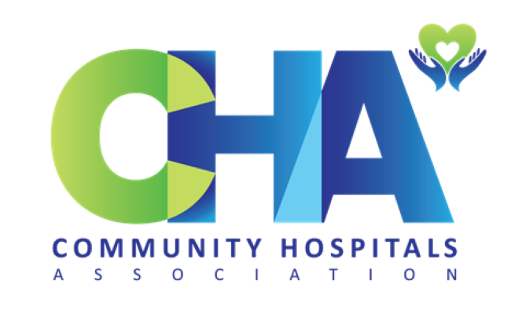

Community Hospitals Association

Membership Application Form 2022

Please complete and email to infocommunityhospitals@gmail.com

Membership Application | Please Complete

Community Hospital

Name

Position

Name of Organisation (if applicable)

Email

Tel. No
Membership for: | £ | Please Tick
Individual | Free!
League of Friends | £100
NHS Trust/ Provider Organisation | £200
Payment Options | Please Tick
Bacs : Community Hospitals Association: Barclays Bank PLC Sort Code: 20-62-53 Account No: 73057348. Please put your name/organisation in reference box
Invoice: An invoice can be emailed on request, with a purchase order.
Contact: Name and Details (if different from above): | Date:

Thank you for applying to join the CHA. You will be sent an email in due course.

